**Project Initialization and Planning Phase**

| Date | 15 March 2024 |
| --- | --- |
| Team ID | 739890 |
| Project Name | Bookmate: A Chatbot Companion For Book Recommendations |
| Maximum Marks | 3 Marks |

**Define Problem Statements (Customer Problem Statement Template):**

In today’s fast-paced world, book lovers often struggle to find personalized book recommendations that align with their unique tastes and reading preferences. Traditional recommendation systems frequently fall short, offering generic suggestions that fail to capture individual preferences, leaving readers dissatisfied or overwhelmed. Additionally, readers may lack a platform for engaging, real-time interaction to explore new genres, authors, or hidden literary gems. This gap highlights the need for a user-friendly, intelligent chatbot companion that not only understands personal interests but also evolves with the reader’s preferences, delivering curated and dynamic book recommendations in an interactive and engaging manner.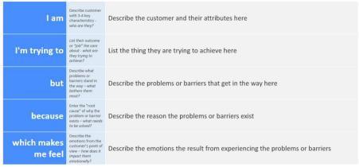

Reference: https://miro.com/templates/customer-problem-statement/

**Example:**

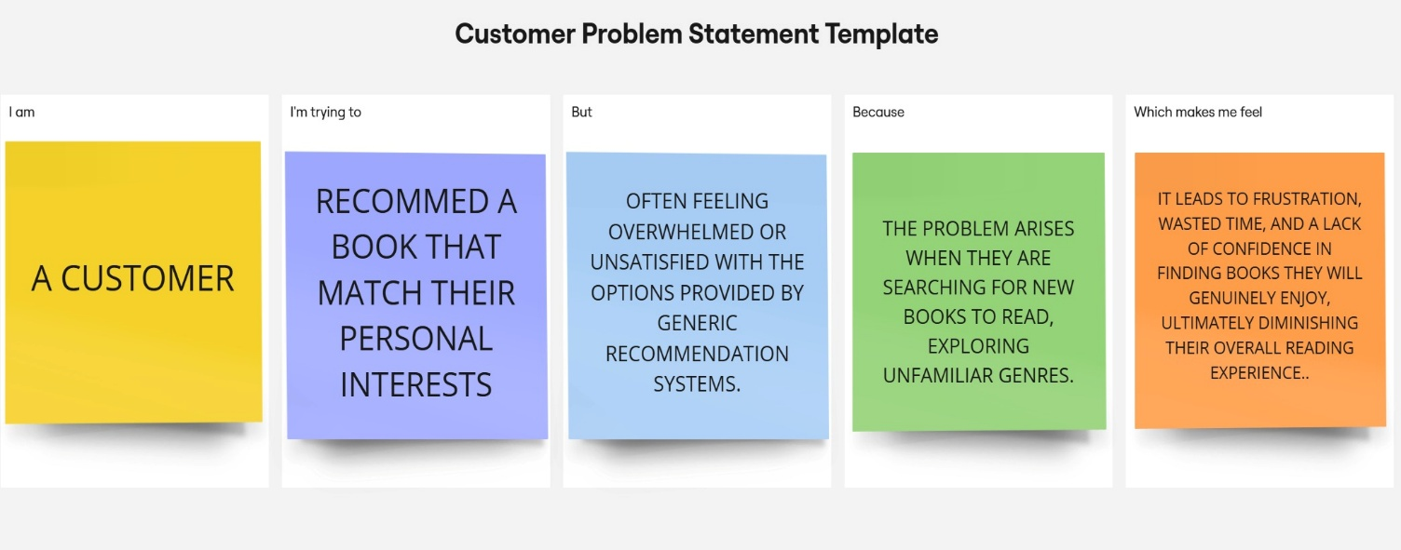

|  |  |  |  |  |  |
| --- | --- | --- | --- | --- | --- |
| **Problem**  **Statement (PS)** | **I am**  **(Customer)** | **I’m trying to** | **But** | **Because** | **Which makes me feel** |
| PS-1 | A reader who enjoys [specific genres/authors/themes] | Discover new books that match my interests | Current recommendation systems are often generic and don't take into account my individual preferences. | I want to spend my time reading books that I will truly enjoy, and not waste time on books that don't interest me. | Frustrated and overwhelmed by the sheer number of books available. |
| PS-2 | A reader who is looking for [specific type of community, e.g., book club,] | Find books similar to ones I've enjoyed | Traditional book clubs and online forums can be overwhelming and don't always cater to my specific interests. | I want to connect with other readers who share my passion for books and have meaningful discussions about them. | Isolated and disconnected from other readers who share my interests. |